A Ministry Assisting People With Spiritual Growth

Survey (circle one)
1. Are you controlled by your actions, behaviors, and choices? Yes No
2. Do you or someone you know need help managing anger? Yes No
3. Is there a besetting sin that keeps you entangled in its web? Yes No
4. Are you or were you abused? Yes No
5. Do you or someone you know need help with substance abuse? Yes No
6. Are you every embarrassed by or do you seek to hide any activity? Yes No
7. Does fear keep you from getting help for your private sins? Yes No
8. Is there a character weakness you’d like to change? Yes No
9. Do you know anyone you can trust to share your life? Yes No
10. Is there a safe place where you can be yourself? Yes No
11. Does the cost of getting help appear to be too great? Yes No
12. Are you currently working a personal program of recovery? Yes No

Other than questions 9, 10, and 12, if you answered yes to any of the above questions, a Christ-Centered 12-Step Recovery Program and/or other 12 Step Recovery Program is for you.

Fold & Tear

Adventist Recovery Ministries
A Ministry of the Health Ministries Department
North American Division of Seventh-day Adventists

Director - Katia Reinert, MSN, CRNP, FNP-BC, PHCNS-BC, FCN
12501 Old Columbia Pike
Silver Spring, MD 20904-6600
Phone: 301-680-6733
Fax: 301-680-6734
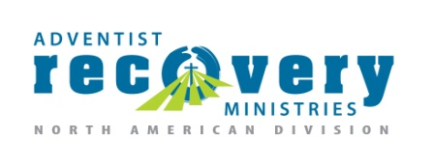
For More Information:
e-mail: recovery@NAD.adventist.org
website: www.adventistrecovery.org

Adventist Recovery Ministries

I am interested in helping people find freedom from harmful habits, obsessive and compulsive thinking

I am willing to participate in The Journey to Wholeness meetings

My name is: ________________________________

My contact information is: ____________________

__________________________________________

Fold & Tear

